**A program for calculating percolation**

1. **Introduction**

The theory of calculation - percolation - describes the physics and mathematics of long-term connections in random systems. And applies to a wide range of physical systems, including conductivity, porosity and polymers. But can also be used to analyze systems such as forest fires, disease epidemics, and social networks.

Is one of the simplest models in probability theory which presents what is known as critical phenomena. This usually means that there is a natural parameter - P in the model where the system behavior changes drastically.

1. **Description of the problem**

For a long time, scientists have investigated the problem of regulation and found a solution for it. Recently, physicists at the college began to deal with the computation of the computation problem for new materials to find the conductivity from one point to another and found that the existing solution of the problem was not enough. Meanwhile they do the calculations manually and it takes them weeks and even months to reach a solution.

And this is the time when our work begins to develop software that will help them in the calculation of prac- tice.

**The problem of the procedure consists of two stages:**

**- Stage A: Accurate calculation of the problem of regulation for a small network.**

Given P-probability existence of the arc in the grid. And G-conductivity. We will go over all the subnet networks that can be obtained and consider the vector of total conductivity values ​​for each subnet and the probability of receiving any value.

**Stage 2: Renormalization.**

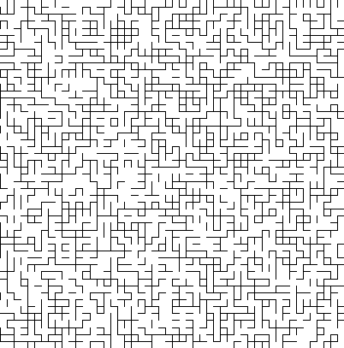At this stage, we take the little grid on which we performed the calculations in phase 1, multiply it several times, and calculate the conductivity vector for the large grid we received

1. **Description of the solution**

We will develop a computer program in the JAVA language that will perform the calculations of stage 1 and stage 2 of the preposition. At the end of the calculations, a table of the possible conductivity values ​​and the probability of obtaining each value will appear to the user.

The code we write should be well divided so that it can be used in the future for all kinds of calculations. For example, the code can be improved so that it calculates a D3 rather than a standard D2.

1. **Review of similar works in the literature and comparison**

There is a solution to the problem of percolation, but it is not enough for calculations made by physicists at the college recently.

B. **Charts and tables**

